**Grazioso Software ReadMe File**

## About the Project/Project Title

Grazioso software is a software application that works with existing data from animal shelters to identify and categorize dogs in nearby dog shelters. The application has authentication features and allow users to perform basic CRUD operations on data that is uploaded to the database of the application.

## Motivation

The Grazioso Software provide a solution for Grazioso Salvare to analyze different dogs from different shelters to help them identify dogs for specific task like search and rescue. This project combines database operation, MongoDB in this case, with python scripting to run CRUD operation on a database. The project more than read and writes operations on a database, it helps one understand other concept in programing like module importing, drivers/modules, etc.

**Functionalities and Steps to reproduce the project.**

* Set up MongoDB database with user authentication (Create users with read/write etc. privileges).
* Upload data (csv format)
* Install necessary python MongoDB packages (eg. Pymongo) and Dash/plotly packages
* Run Dashboard (ipynb file)
* The dashboard file uses the animal_shelter.py model file to perform CRUD operation on the data base to create, read, update, and delete collections and documents in the database.
* Interact with the data by using the filtering input to filter preferences on the database.

**MongoDB Database**

MongoDB was chosen as the Database because as a document database, it offers scalability and flexibility with querying and indexing features. In the case of this project, The AAC animal records/data which is in a csv format is uploaded into the database as an animal collection. With the help of python package pymongo, CRUD module is able to communicate with MongoDB by instantiating an authenticated MongoClient and perform operation on the database.

**Dash Framework**

The design of this project followed the Model View Controller (MVC) architecture. The model was created in the animal_shelter.py file to help connect with and perform CRUD operation on MongDB. The view and controller were developed in the Dashboard file to help the user view data from the data base in a interactive manner. Dash, ash is a high level UI framework that is purpose-built for building interactive UI with python was used for the View part of the project. Dash was used to create input, chart, graph and map widget to help the user view and filter the data accordingly.

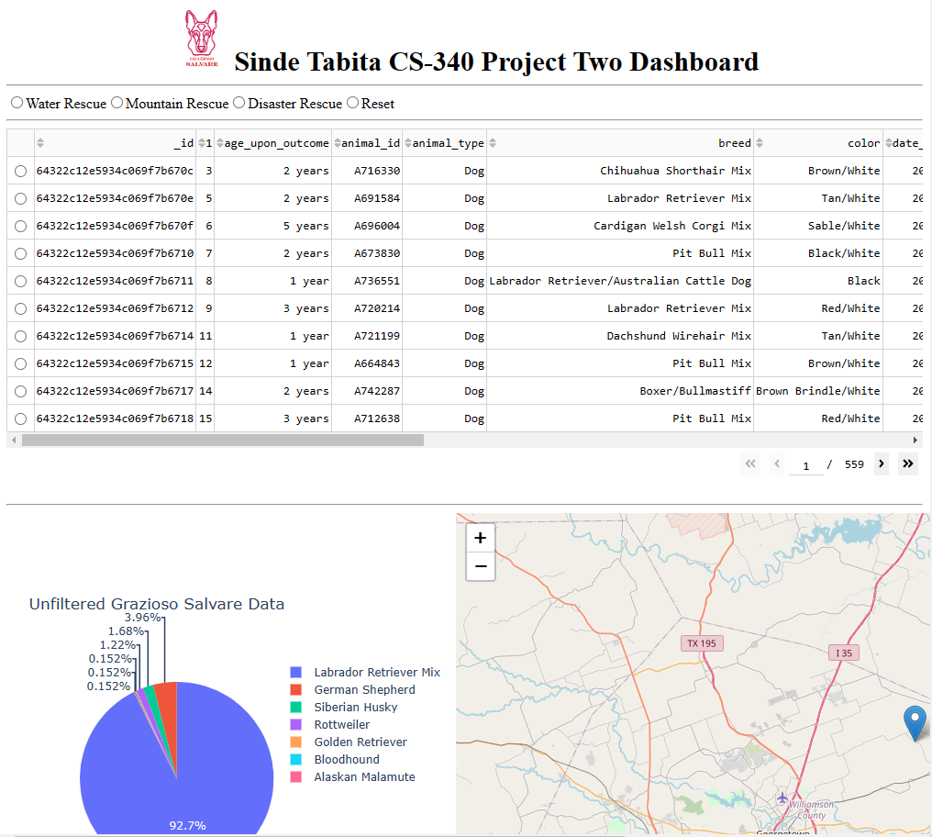**Screenshots of the Dashboard and various filtering functionalities**

*Query the database for only animals that are dogs.*

*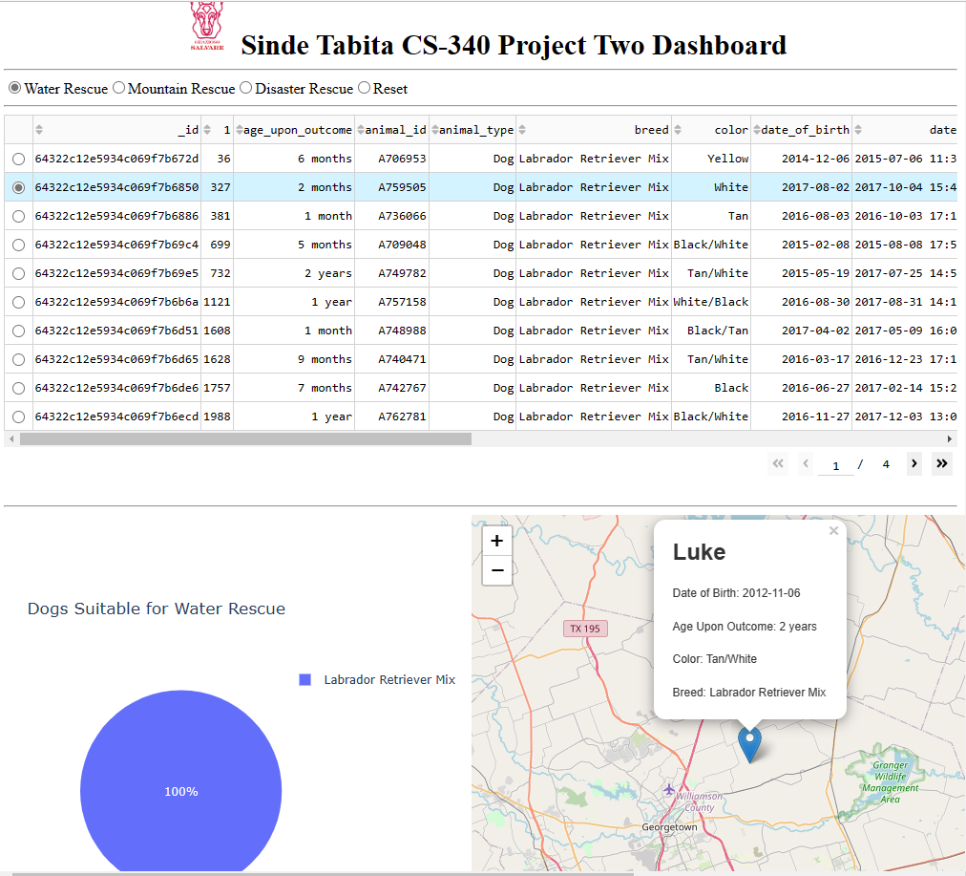Filter Dogs that are preferred for water rescue. Select a dog from the table and click on the geolocation pin to view information about the dog. The geolocation marks the place the dog was taken from.*

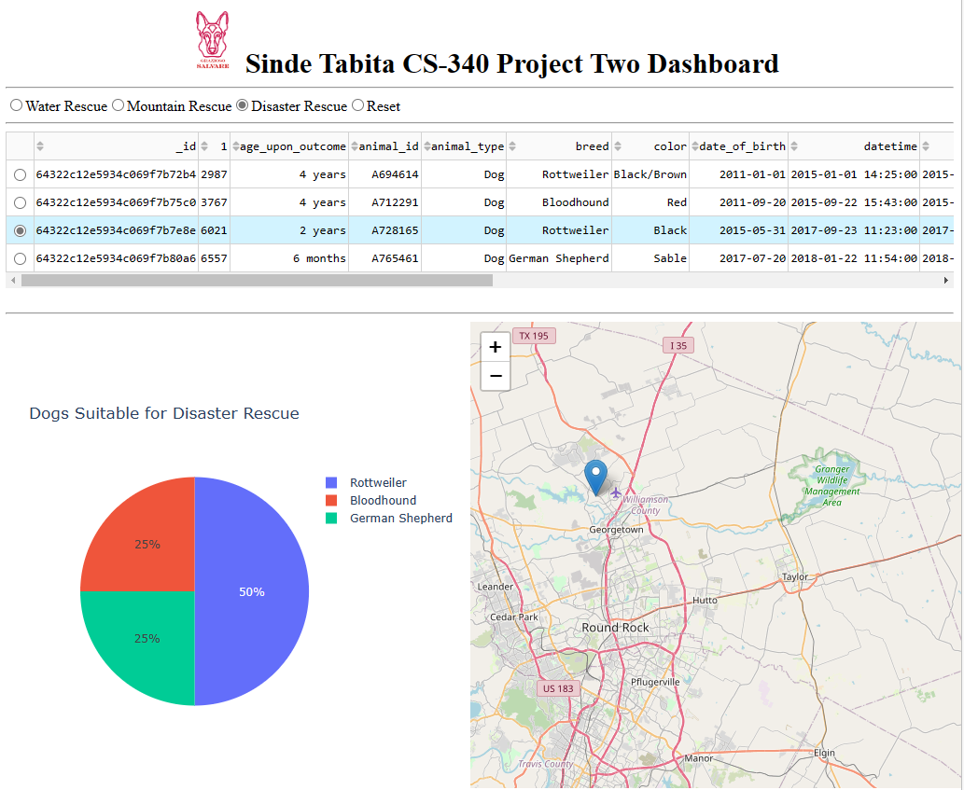

*Use the filter to view Dogs that are preferred for Disaster rescue. View a breakdown of the breed of dogs who fall under this category.*

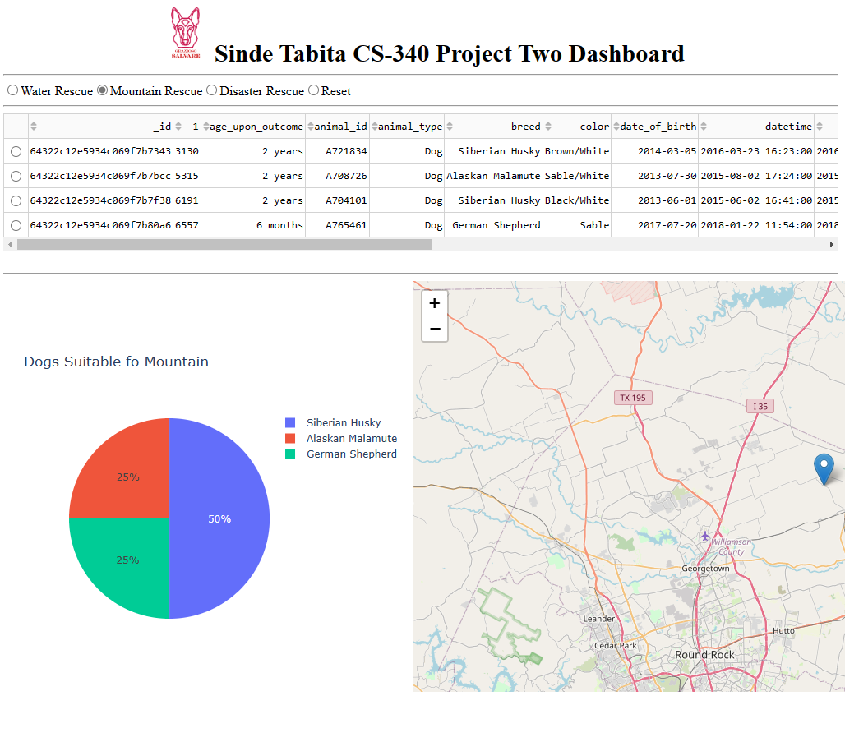

*You can click on the logo at the top of the screen to visit Grazioso Salvare website for more information about their work.*

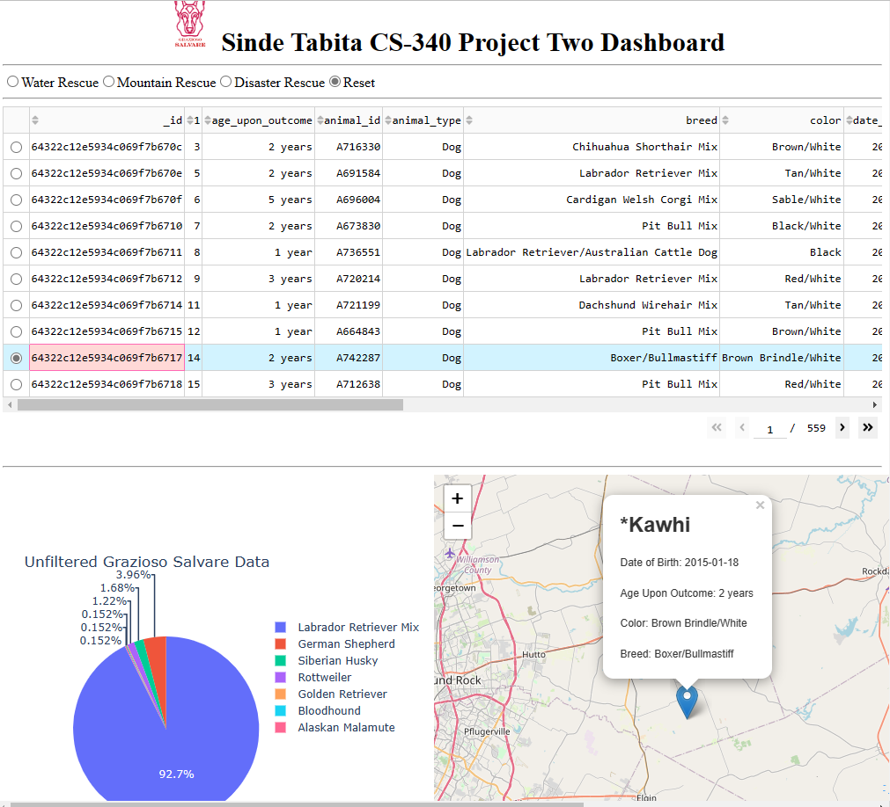

*Use the reset button to reset the data and pie chart after filter.*